Registration for the 8th EAWOP Early Career Summer School is now extended!
The EAWOP Early Career Summer School for Advanced Work and Organizational Psychology (W/O) brings together 36 early career scholars from all over Europe for an eighth time in 2022. This event presents the unique opportunity for young researchers to meet with fellow researchers and prominent professors and to discuss their own work as well as aspects of being a researcher. Committed to this biannual, extraordinary meeting, and certain about its potential to be a transformative event for young scholars in the field of W/O psychology, the Cyprus Institute of Marketing and its independent Cyprus Centre for Business Research are hosting the 8th EAWOP Early Career Summer School in Protaras, Cyprus, from the 7th to the 11th of June 2022.
Summer School Objectives
The 8th EAWOP Early Career Summer School for Advanced Work and Organizational psychology will empower European research in the field of W/O psychology, set key guidelines and help in establishing strong networks for future collaborative research. Specifically, the planned summer school has six specific objectives:
1. To increase the quality of European W/O psychology research by supporting and providing early stage researchers the chance to interact with senior scholars in the area. This will allow them to obtain better understanding of how to conduct impactful research, get feedback on current research projects and to generate new and interesting ideas for collaborative research.
2. To enhance participants’ valuable skill-sets in production of high quality research, funding application and management of research projects as well as editing and publication in leading European and international journals.
3. To generate and share feedback concerning future career steps and get insights into aspects of a successful scientific career by senior scholars to facilitate participants’ career development in academia and become prolific and rigorous researchers.
4. To foster and establish European research collaborations by creating a solid network of ambitious up-and-coming researchers. This will further strengthen the European W/O community among participants and senior academics who will be involved as keynotes or session facilitators in the summer school.
5. To bring together scientist and practitioner perspectives of W/O Psychologists and support the application of scientific outcomes; at the same time, to enlighten the scientific community about actual needs of practitioners.
6. To raise awareness among participants about real-world challenges of modern organizations and discuss key elements of engaged scholarship and actionable knowledge. In an attempt to effectively bridge the gap between academia to practice, we choose to invite scholars whose work cuts across the fields of academia and consulting.

Invited senior scholars
- Almuth Mcdowall, Professor of Organizational Psychology, Department of Organizational Psychology and Assistant Dean, OP, School of Business, Economics & Informatics, Birkbeck, University of London
- Karina Nielsen, Professor and Chair in Work Psychology, Sheffield University Management School, University of Sheffield
- Sandra Ohly, Professor of Business Psychology, University of Kassel
- Wilmar Schaufeli, Professor of Work and Organizational Psychology, Utrecht University
- Despoina Xanthopoulou, Associate Professor in Organizational Psychology, Department of Social and Clinical Psychology, Aristotle University of Thessaloniki
- Matthew Davis, Associate Professor in Organizational Psychology, Leeds University Business School, University of Leeds
Summer school Activities
The summer school consist of a variety of activities including:
- Keynote presentations from distinguished invited senior Scholars
- Interactive Poster Session
- Roundtables (Two supervised group sessions)
- Research Methods Workshops
- Skills Workshops
- Excursions & Social activities
Provisional Programme
TIME | Tuesday 7th June 2022 | Wednesday 8th June 2022 | Thursday 9th June 2022 | Friday 10th June 2022 | Saturday 11th June 2022
8.00-8.30 | Arrival & Registration | Breakfast | Breakfast | Breakfast | Breakfast
8.30-9.00
9.00-9.30 |  | Keynote 1: The past, present and future of Occupational Health Psychology, Prof. Wilmar Schaufeli | Keynote 2: Different Types of Resources at Work: Their Role for Employee Functioning, Assoc. Prof. Despoina Xanthopoulou | Keynote 3: Implementing organisational interventions, Prof. Karina Nielsen | Keynote 4: Bridging the research-practice agenda, Prof. Almuth Mcdowall
9.30-10.00
10.00-10.30
10.30-11.00 |  | Coffee Break | Coffee Break | Coffee Break | Coffee Break
11.00-11.30 |  | Interactive Posters Session | Roundtable 1 | Roundtable 2 | Research Methods Workshop 3: Diary Studies in Organizations: What, Why and How?, Assoc. Prof. Despoina Xanthopoulou
11.30-12.00
12.00-12.30
12.30-13.00 |  |  |  |  | Lunch
13.00-13.30 |  | Lunch | Lunch | Lunch
13.30-14.00
14.00-14.30 |  | Research Methods Workshop 1: Application of Socio-Technical System framework, Assoc. Prof. Matthew Davis | Skills Workshop 2: Journal Publication, Prof Sanda Ohly | Research Methods Workshop 2: Planning your “own” intervention, Prof. Karina Nielsen | Networking & Conclusion
14.30-15.00
15.00-15.30
15.30-16.00 |  | Coffee Break | Boat Trip to Sea Caves, Cape Greco National Park | Visit to Winery & Dinner
16.00-16.30 |  | Skills Workshop 1: Career management for science practitioners, Prof. Almuth Mcdowall |  |  | Departure
16.30-17.00
17.00-17.30 | Welcome Reception & Opening  EAWOP Summer School
17.30-18.00 |  | Visit Prof. Elias Church Hill | Dinner
18.00-18.30 | Dinner
18.30-19.00 |  | Dinner
The final programme for this year’s summer school will be published later.

Destination
Cyprus is a beautiful, warm island in the Mediterranean with great history and a key geographical location at the crossroads of three continents: Europe, Asia and Africa. Besides its convenient, easy-to-navigate size and the easy transportation network, it would be an ideal location for a summer school, the mild temperatures in June allowing for trips and excursions. Protaras is located in the East Coast of Cyprus. It is one of the most popular coastal destinations of the island, ideal for holidays and relaxation. It beautifully blends together the rural nature of Cape Greco national park and the amazing sea view of the Mediterranean. It’s close to the main international airport but its convenient location also allows visitors to easily travel to the mountains. And it is of course right by the sea and the venue of the island’s most beautiful and cleanest beaches. A further advantage is that there are several excellent accommodation options. It will be an attractive location for young and senior academics to gather, network, learn from each other, and think about important Organizational Psychology topics and research all the while enjoying the beauties of the island.
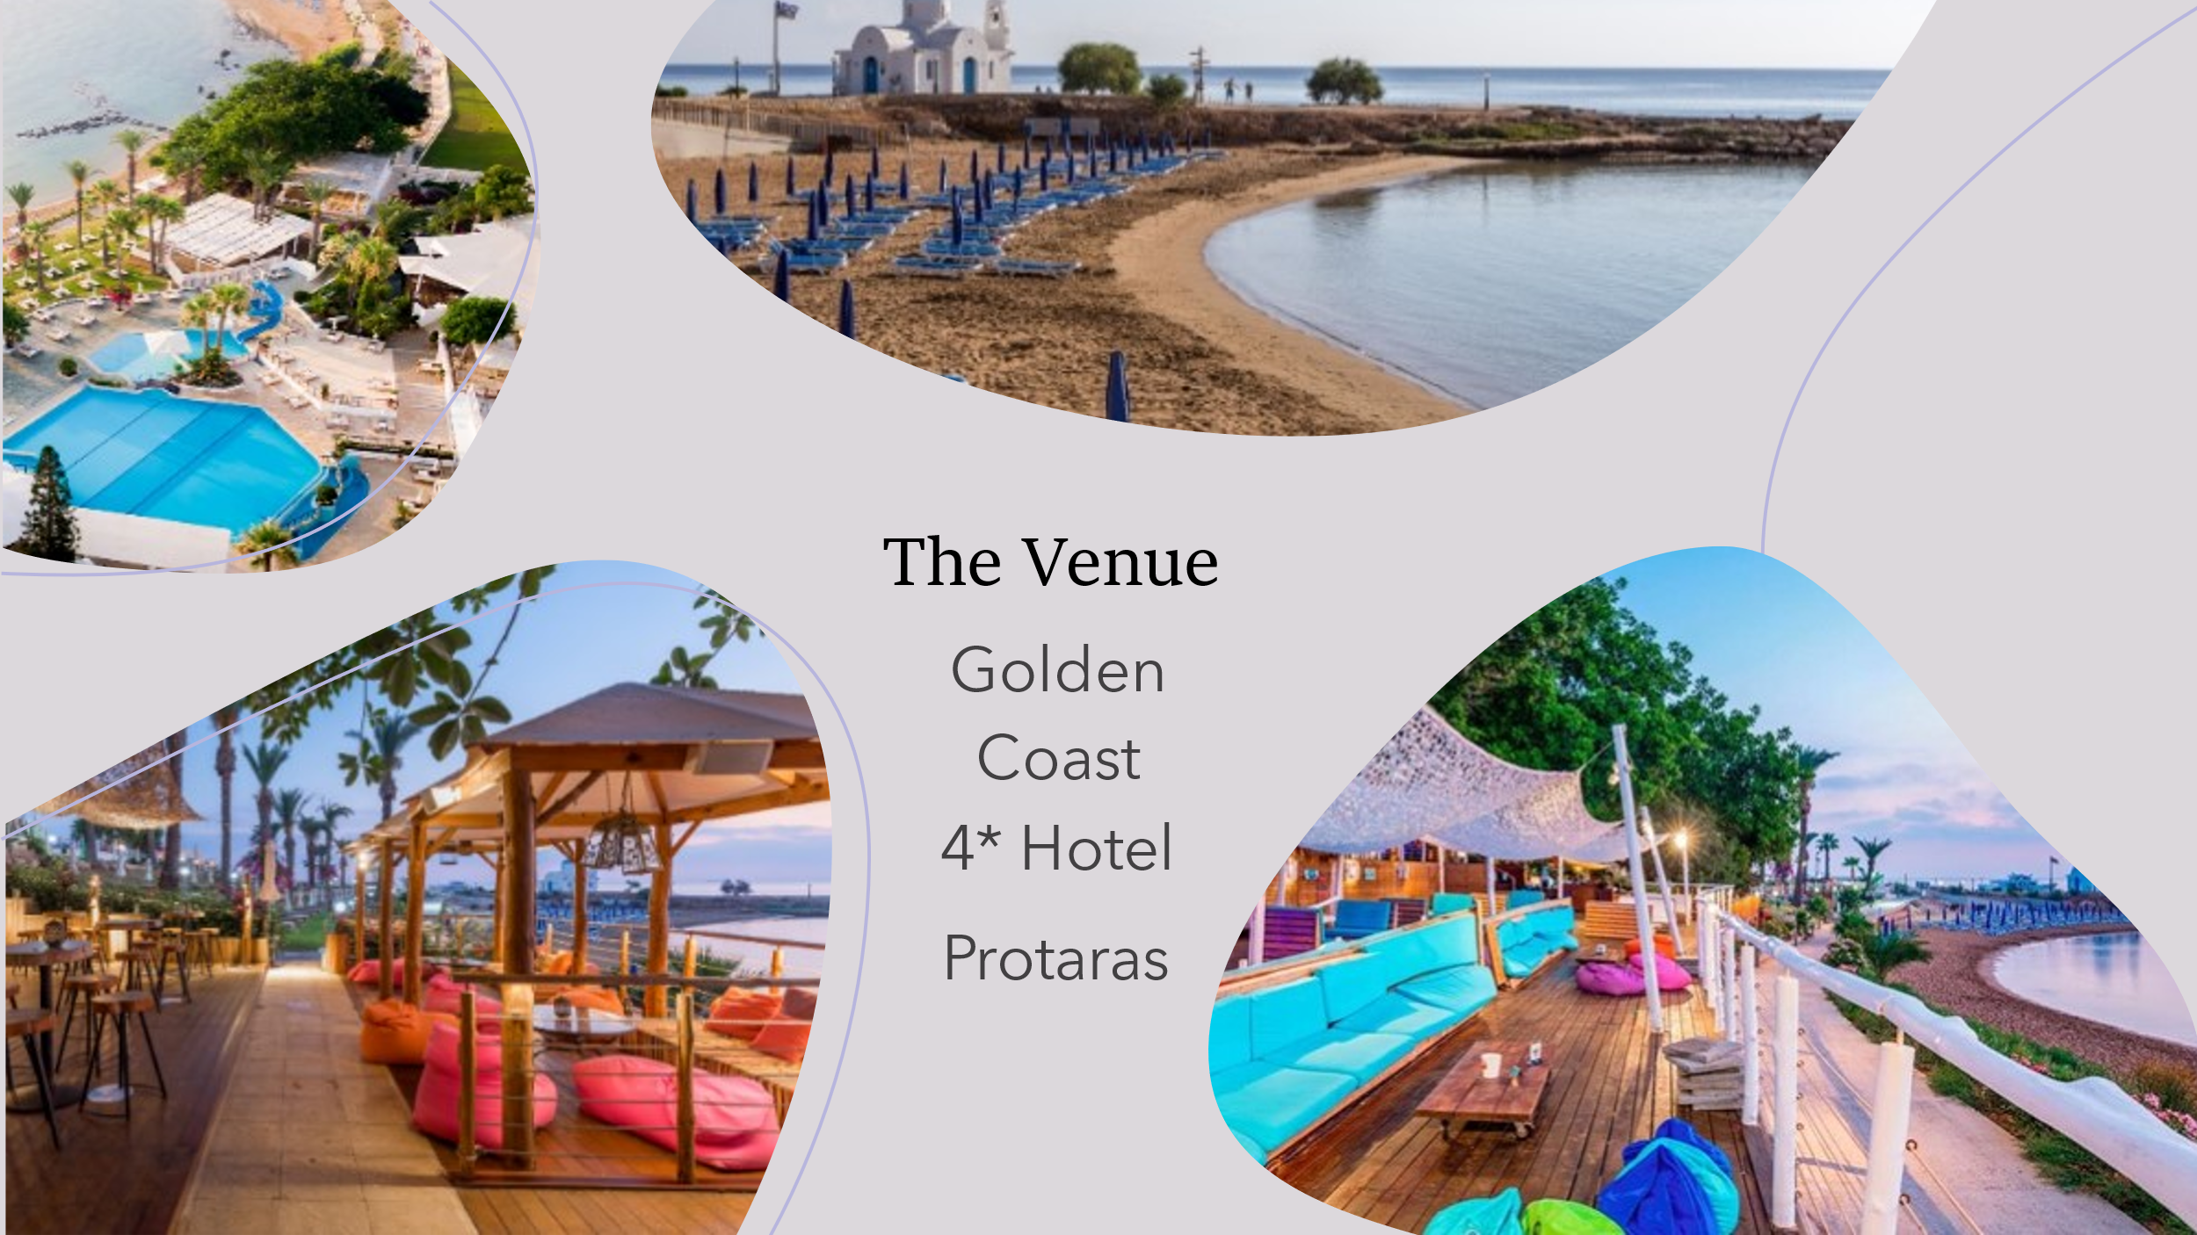
Excursions & Social activities:
There will be several social activities, including an opening ceremony on the first evening and three visits. The first visit will be a short walking distance trip to the well-known Profitis Elias Church, built at the top of the hill and the highest spot in Protaras. Delegates will enjoy the panoramic view of the sunsets over Famagusta district. The second visit will include a boat trip at the sea caves at Cape Greco National Forest Park. The third trip will be in Omodos village on the Troodos mountains and will include a visit at a winery, a briefing about the processes of wine making, tour at the famous vineyards of the area, and a dinner at a traditional tavern nearby.
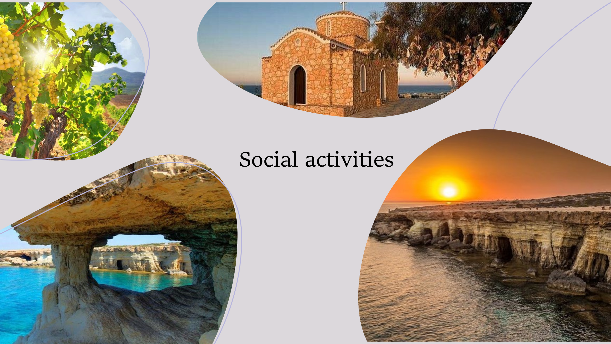

Participation
Eligible participants at the summer schools are:
- Early career scholars in the field (who have obtained their PhD within the last 5 years);
- PhD students in their final year.
Organizing Committee:
- Georgia Thrasyvoulou, Director of Student Affairs and HR & Lecturer in Organizational Psychology, Cyprus Institute of Marketing, email: georgia.t@cima.ac.cy
- Evie Michaelides, Lecturer in Occupational & Organizational Psychology, Cyprus Institute of Marketing
- Maria Charalambous, Lecturer in Business & Occupational Psychology & Post-Doctoral Research Fellow, Cyprus Institute of Marketing
- Katerina Pavlou, Director of CCBR & Academic Director, Cyprus Institute of Marketing-Limassol Campus
- Constantinos Constantinou, Director of Research & Head of Undergraduate Studies, Cyprus Institute of Marketing
- Christos Hadjiyiannis, Dean, Cyprus Institute of Marketing
More information can be found in the Summer School leaflet, here, or by sending an email to eawopss2022@outlook.com
To register, please follow the link here, until the 30th of January 2022

